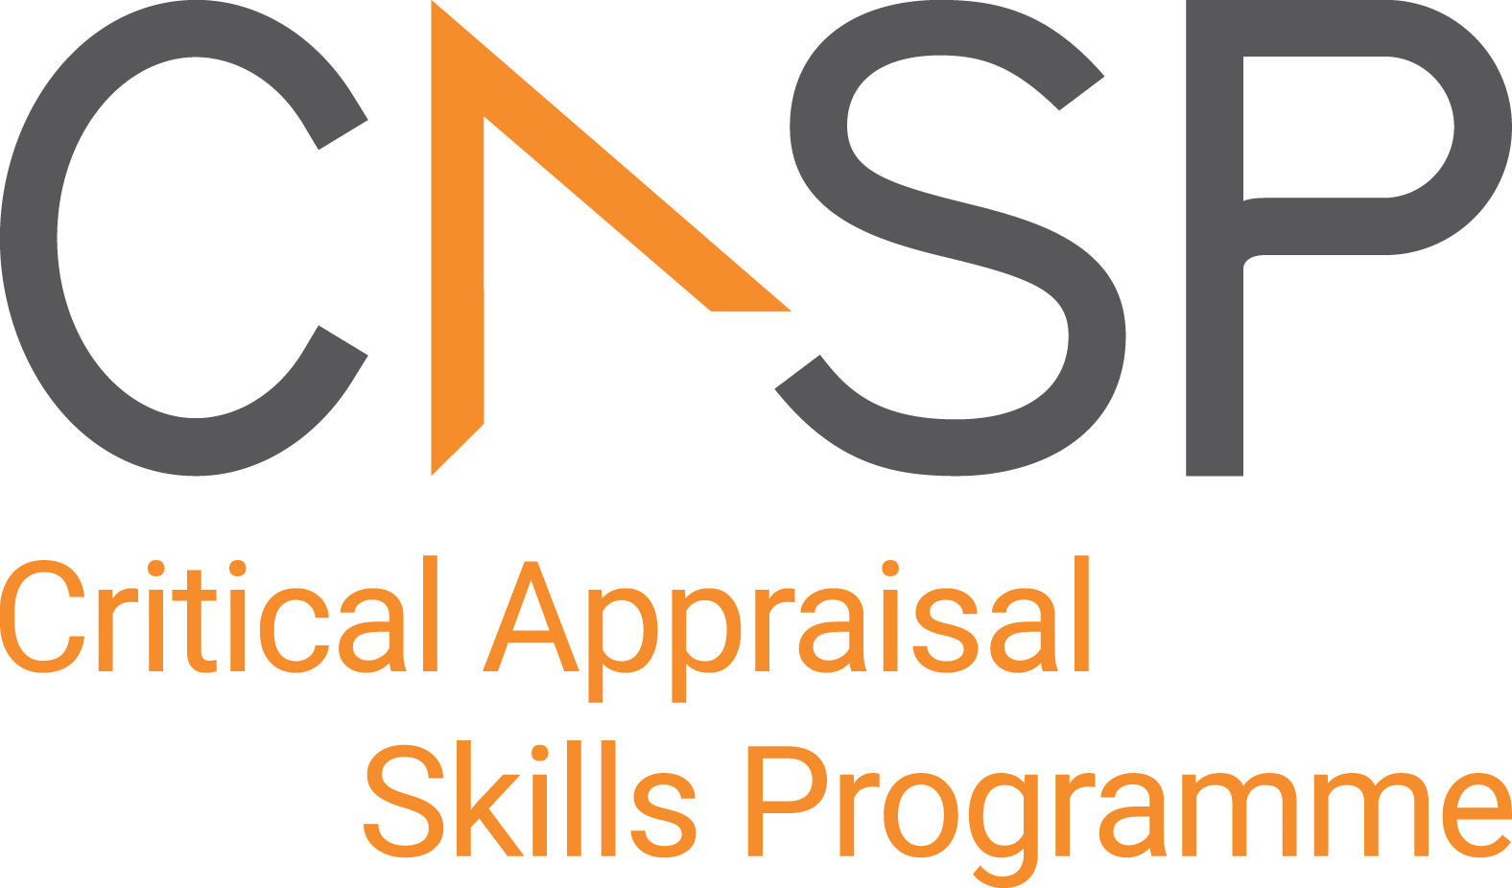
CASP Checklist:
For diagnostic test studies

Reviewer Name:
Paper Title:
Author:
Web Link:
Appraisal Date:

During critical appraisal, never make assumptions about what the researchers have done. If it is not possible to tell, use the “Can’t tell” response box. If you can’t tell, at best it means the researchers have not been explicit or transparent, but at worst it could mean the researchers have not undertaken a particular task or process. Once you’ve finished the critical appraisal, if there are a large number of “Can’t tell” responses, consider whether the findings of the study are trustworthy and interpret the results with caution.

Section A: Are the results of the study valid?

- Did the study address a clearly formulated research question? | Yes No Can’t Tell
CONSIDER:
A question should include information about
- the population
- the test
- the setting
- the outcomes
- Was there a comparison with an appropriate reference standard? | Yes No Can’t Tell
CONSIDER:
- Is this reference test(s) the best available indicator in the circumstances
- Did all patients get the diagnostic test and reference standard? | Yes No Can’t Tell
CONSIDER:
- were both received regardless of the results of the test of interest
- Check the 2x2 table (verification bias)
- Could the results of the test have been influenced by the results of the reference standard? | Yes No Can’t Tell
CONSIDER:
- was there blinding
- were the tests performed independently
- could there have been review bias
- Is the disease status of the tested population clearly described? | Yes No Can’t Tell
CONSIDER:
- presenting symptoms
- disease stage of severity
- co-morbidity
- differential diagnoses (spectrum bias)
- Were the methods for performing the test described in sufficient detail? | Yes No Can’t Tell
CONSIDER:
- Was a protocol followed
Section B: What are the results?

- What are the results? |  | Yes No Can’t Tell
CONSIDER:
- are the sensitivity and specificity and/or likelihood ratios presented
- are the results presented in such a way that we can work them out
- How sure are we about the results? Consequences and cost of alternatives performed? |  | Yes No Can’t Tell
CONSIDER:
- could they have occurred by chance
- are there confidence limits
- what are they
Section C: Will the results help locally?

- Can the results be applied to your patients/the population of interest? |  | Yes No Can’t Tell
CONSIDER:
- Do you think your patients/population are so different from those in the study that the results cannot be applied, such as age, sex, ethnicity and spectrum bias.

- Can the test be applied to your patient or population of interest? | Yes No Can’t Tell
CONSIDER:
- resources and opportunity costs
- level and availability of expertise required to interpret the tests
- current practice and availability of services
- Were all outcomes important to the individual or population considered? | Yes No Can’t Tell
CONSIDER:
- will the knowledge of the test result improve patient wellbeing
- will the knowledge of the test result lead to a change in patient management
- What would be the impact of using this test on your patients/population?

APPRAISAL SUMMARY: List key points from your critical appraisal that need to be considered when assessing the validity of the results and their usefulness in decision-making.
Positive/Methodologically sound | Negative/Relatively poor methodology | Unknowns

Referencing recommendation:

CASP recommends using the Harvard style referencing, which is an author/date method. Sources are cited within the body of your assignment by giving the name of the author(s) followed by the date of publication. All other details about the publication are given in the list of references or bibliography at the end.

Example:

Critical Appraisal Skills Programme (2024). CASP (insert name of checklist i.e. Diagnostic test Checklist.) [online] Available at: insert URL. Accessed: insert date accessed.

Creative Commons

©CASP this work is licensed under the Creative Commons Attribution – Non-Commercial- Share A like. To view a copy of this licence, visit https://creativecommons.org/licenses/by-nc-sa/4.0/


Need further training on evidence-based decision making? Our online training courses are helpful for healthcare educational researchers and any other learners who:

- Need to critically appraise and stay abreast of the healthcare research literature as part of their clinical duties.
- Are considering carrying out research & developing their own research projects.
- Make decisions in their role, whether that be policy making or patient facing.

Benefits of CASP Training:

- Affordable – courses start from as little as £6
- Professional training – leading experts in critical appraisal training
- Self-directed study – complete each course in your own time
- 12 months access – revisit areas you aren’t sure of and revise
- CPD certification - after each completed module

Scan the QR code below or visit https://casp-uk.net/critical-appraisal-online-training-courses/ for more information and to start learning more.

