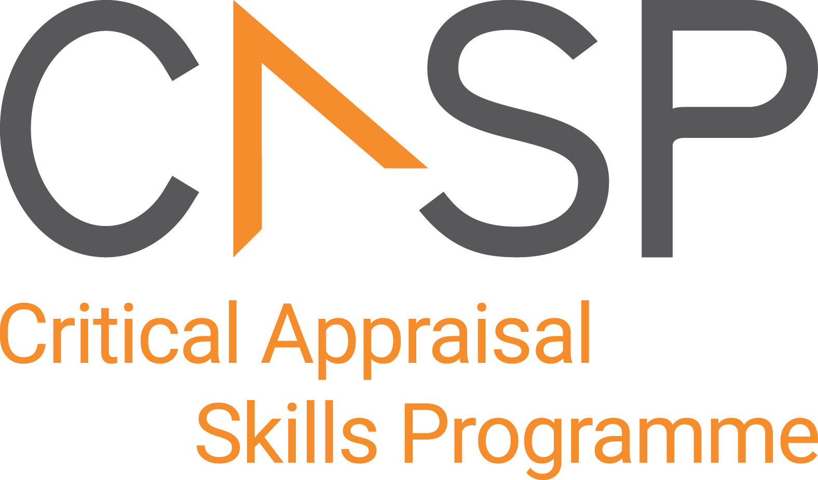
CASP Checklist:
For economic evaluations

Reviewer Name:
Paper Title:
Author:
Web Link:
Appraisal Date:

During critical appraisal, never make assumptions about what the researchers have done. If it is not possible to tell, use the “Can’t tell” response box. If you can’t tell, at best it means the researchers have not been explicit or transparent, but at worst it could mean the researchers have not undertaken a particular task or process. Once you’ve finished the critical appraisal, if there are a large number of “Can’t tell” responses, consider whether the findings of the study are trustworthy and interpret the results with caution.

Section A: Is the economic evaluation valid?

- Was a well-defined question posed? | Yes No Can’t Tell
CONSIDER:
Is it clear what the authors are trying to achieve
- what is the perspective
- how many options are compared
- are both costs and consequences considered
- what is the time horizon
- Was a comprehensive description of the competing alternatives given? | Yes No Can’t Tell
CONSIDER:
Is there a clear decision tree (or similar given):
- can you tell who did what, to whom, where and how often
- Does the paper provide evidence that the programme would be effective?  (i.e. would the programme do more good than harm?) | Yes No Can’t Tell
CONSIDER:
- if an RCT or systematic review was used; if not, consider how strong the evidence was (economic evaluations frequently have to integrate different types of knowledge stemming from different study designs)
- Were the effects of the intervention identified, measured and valued appropriately? | Yes No Can’t Tell
CONSIDER:
- Effects can be measured in natural units (e.g. years of life) or more complex units (e.g. years adjusted for quality of life such as as QALYS) or monetary equivalents of the benefit gained (e.g. $)
Section B: How were consequences and costs assessed and compared?

- Were all important and relevant resources required, and health outcome costs for each alternative identified, measured in appropriate units and valued credibly? | Yes No Can’t Tell
CONSIDER:
Identified?
- remember the perspective being taken
- HINT: measured accurately?
- appropriate units may be hours of nursing time, number of physician visits, years-of-life gained etc.
- HINT: valued credibly?
- are the values realistic
- how have they been derived
- have opportunity costs been considered
- Were costs and consequences adjusted for different times at which they occurred (discounting)? | Yes No Can’t Tell
- What were the results of the evaluation? | Yes No Can’t Tell
CONSIDER:
- what is the bottom line
- what units were used (e.g. cost/life year gained, cost/QALY, net benefit)
- Was an incremental analysis of the consequences and cost of alternatives performed? |  | Yes No Can’t Tell
- Was an adequate sensitivity analysis performed? |  | Yes No Can’t Tell
CONSIDER:
- if all the main areas of uncertainty were considered by changing the estimate of the variable and
- looking at how this would change the result of the economic evaluation
Section C: Will the results help in purchasing for local people?

- Is the programme likely to be equally effective in your context or setting? |  | Yes No Can’t Tell
CONSIDER:
- if the patients covered could be sufficiently different to your population to cause concern
- If your local setting is likely to differ much
- Are the costs translatable to your setting? |  | Yes No Can’t Tell
- Is it worth doing in your setting? | Yes No Can’t Tell

APPRAISAL SUMMARY: List key points from your critical appraisal that need to be considered when assessing the validity of the results and their usefulness in decision-making.
Positive/Methodologically sound | Negative/Relatively poor methodology | Unknowns

Referencing recommendation:

CASP recommends using the Harvard style referencing, which is an author/date method. Sources are cited within the body of your assignment by giving the name of the author(s) followed by the date of publication. All other details about the publication are given in the list of references or bibliography at the end.

Example:

Critical Appraisal Skills Programme (2024). CASP (insert name of checklist i.e. economic evaluation Checklist.) [online] Available at: insert URL. Accessed: insert date accessed.

Creative Commons

©CASP this work is licensed under the Creative Commons Attribution – Non-Commercial- Share A like. To view a copy of this licence, visit https://creativecommons.org/licenses/by-nc-sa/4.0/


Need further training on evidence-based decision making? Our online training courses are helpful for healthcare educational researchers and any other learners who:

- Need to critically appraise and stay abreast of the healthcare research literature as part of their clinical duties.
- Are considering carrying out research & developing their own research projects.
- Make decisions in their role, whether that be policy making or patient facing.

Benefits of CASP Training:

- Affordable – courses start from as little as £6
- Professional training – leading experts in critical appraisal training
- Self-directed study – complete each course in your own time
- 12 months access – revisit areas you aren’t sure of and revise
- CPD certification - after each completed module

Scan the QR code below or visit https://casp-uk.net/critical-appraisal-online-training-courses/ for more information and to start learning more.

